# Program Design

To understand the program better we wrote the main functions on a white board

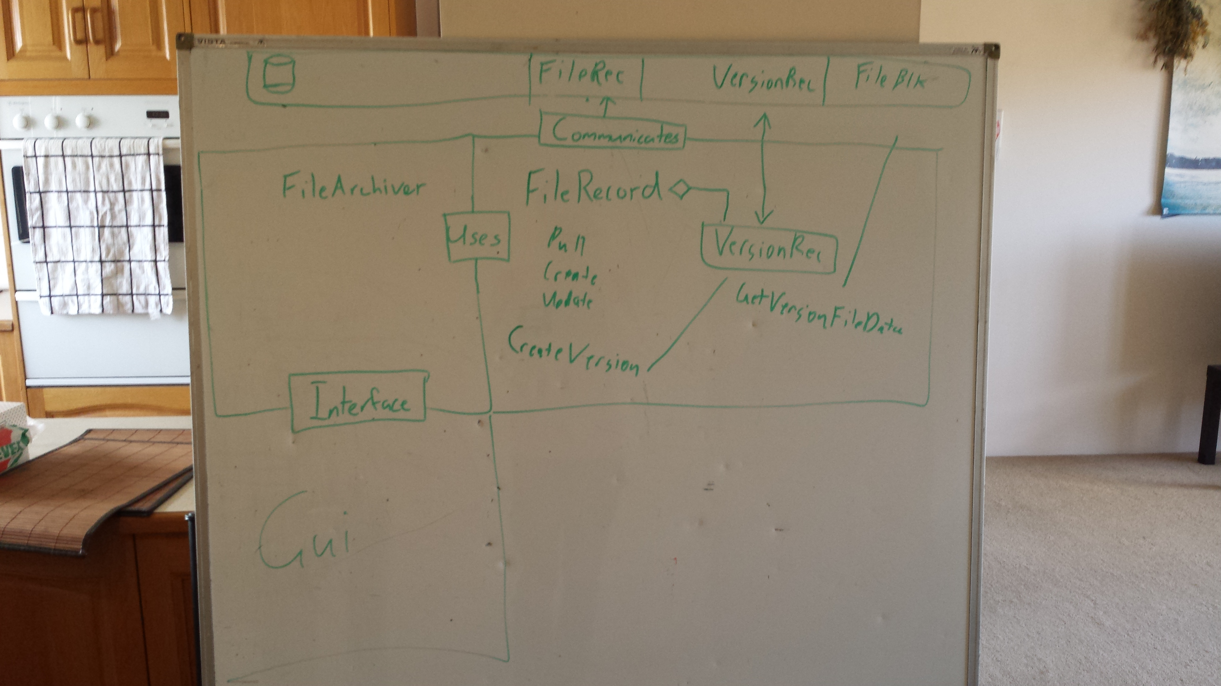

This gave a good starting point. From here we began to flesh it out and understand what functions were needed and how to communicate between the different components.

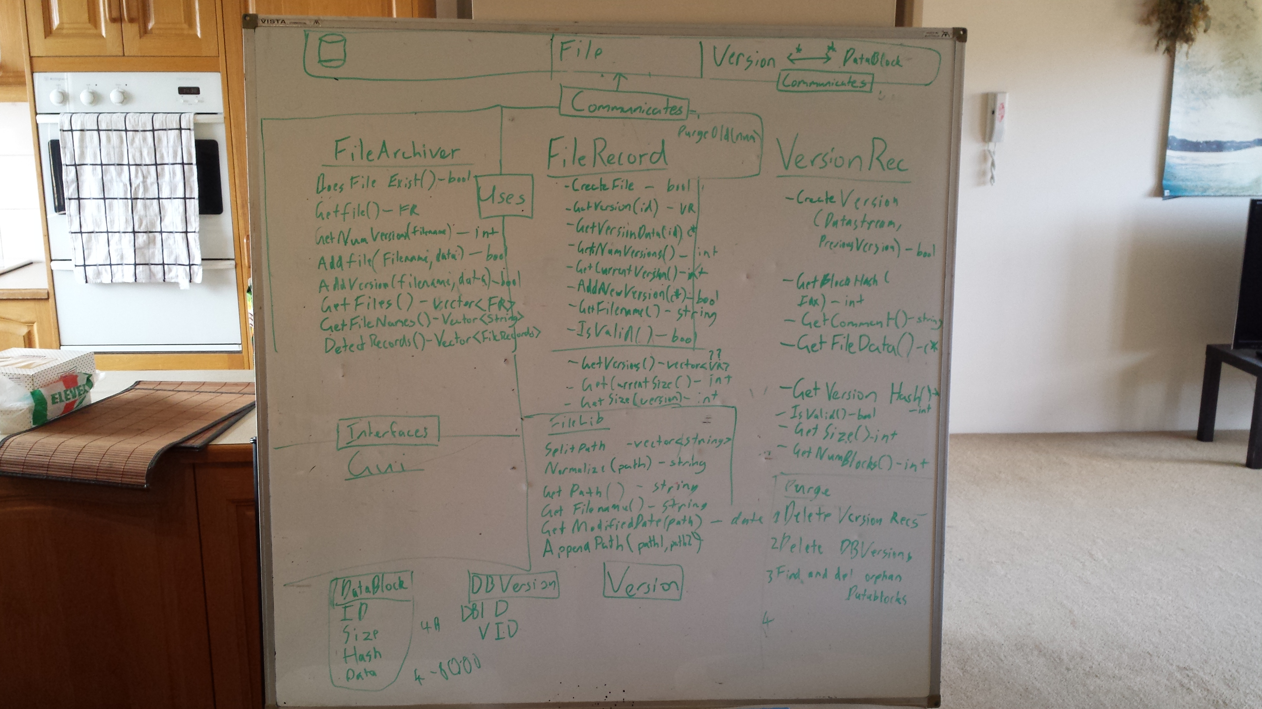Expansion from the starting point, designed to provide, at a glance an overview of the structure of the entire program, to provide insight into program flow and to highlight any area’s where improvements could be made.

The further we got the better we understand what we were working towards. We were able to trim excess functions and remove anything that was doubled up.

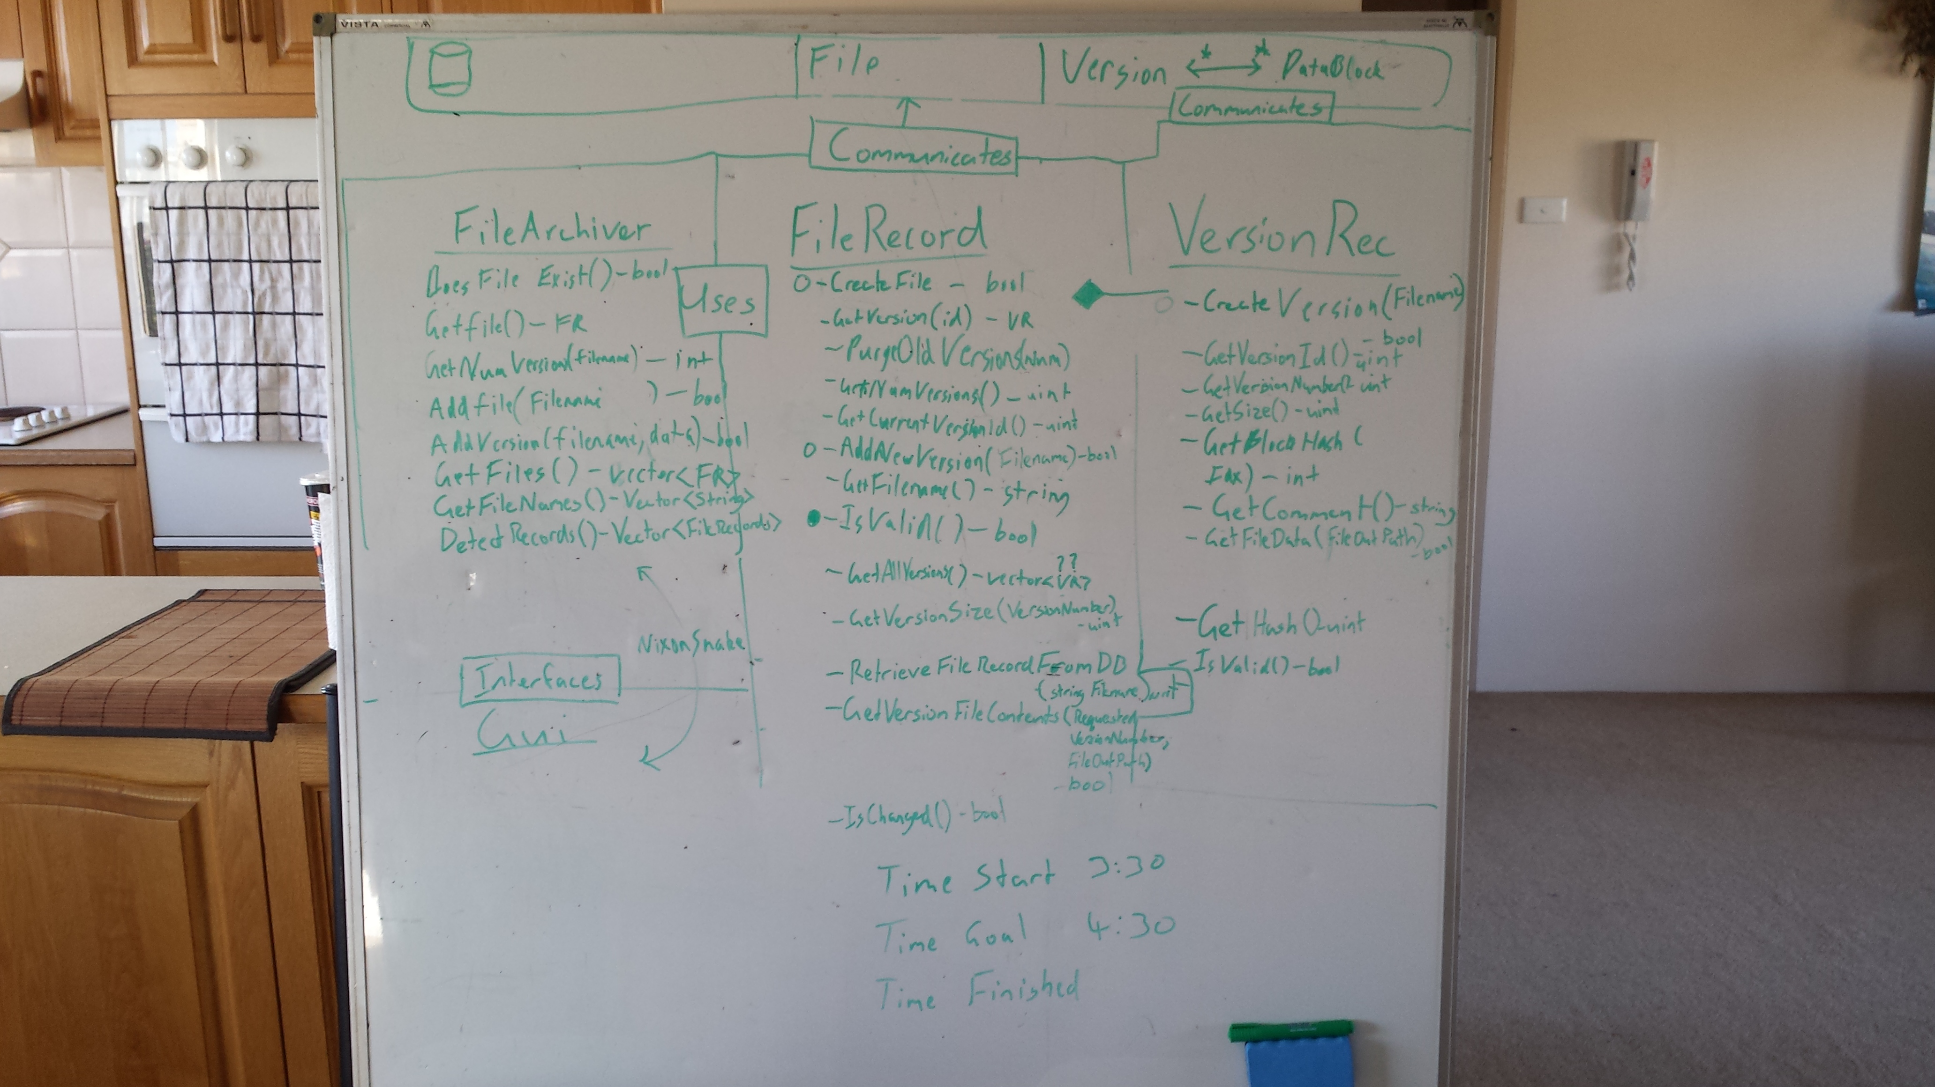

All the class files were designed from this initial layout. From here we decided to get some of the core functionality going.

Database connection.

Creating a FileRecord.

Creating a VersionRec.

Storing a file in the database.

Retrieving a file from the database.

Storing multiple versions.

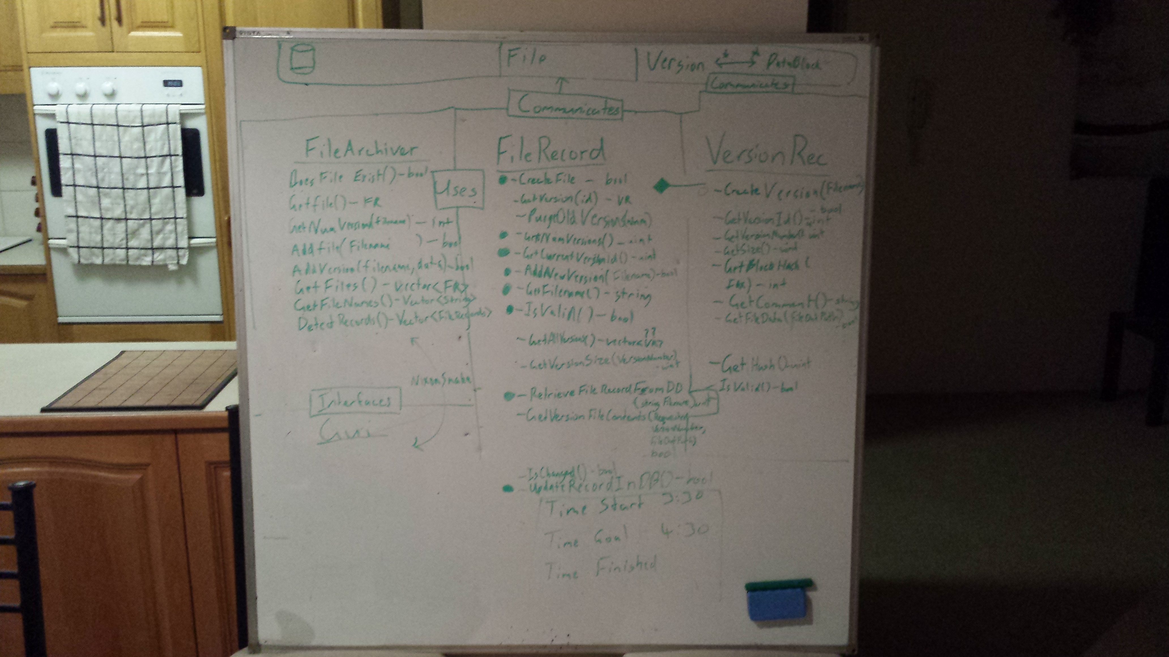

The whiteboard was also used to help us come up with logic in some of the functions. That  
way two people could look at it and make sure it made sense before implementing.

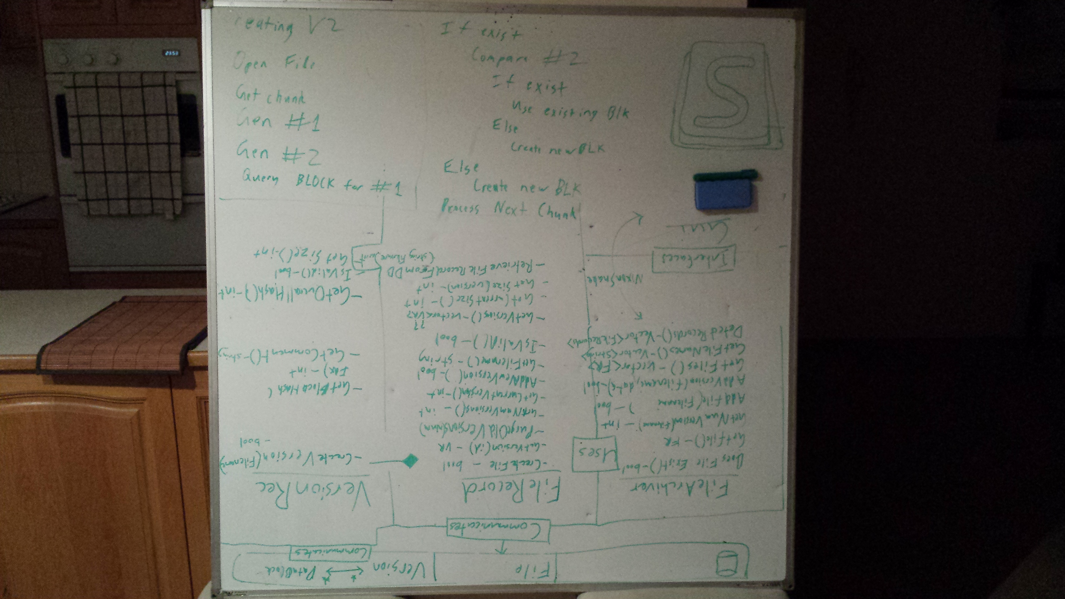

When looking at how to store the data of the file we decided to break the file down into blocks. These blocks would be linked to a version with the intermediate table VtoB which would keep track of the blocks required for a version file and the appropriate index.

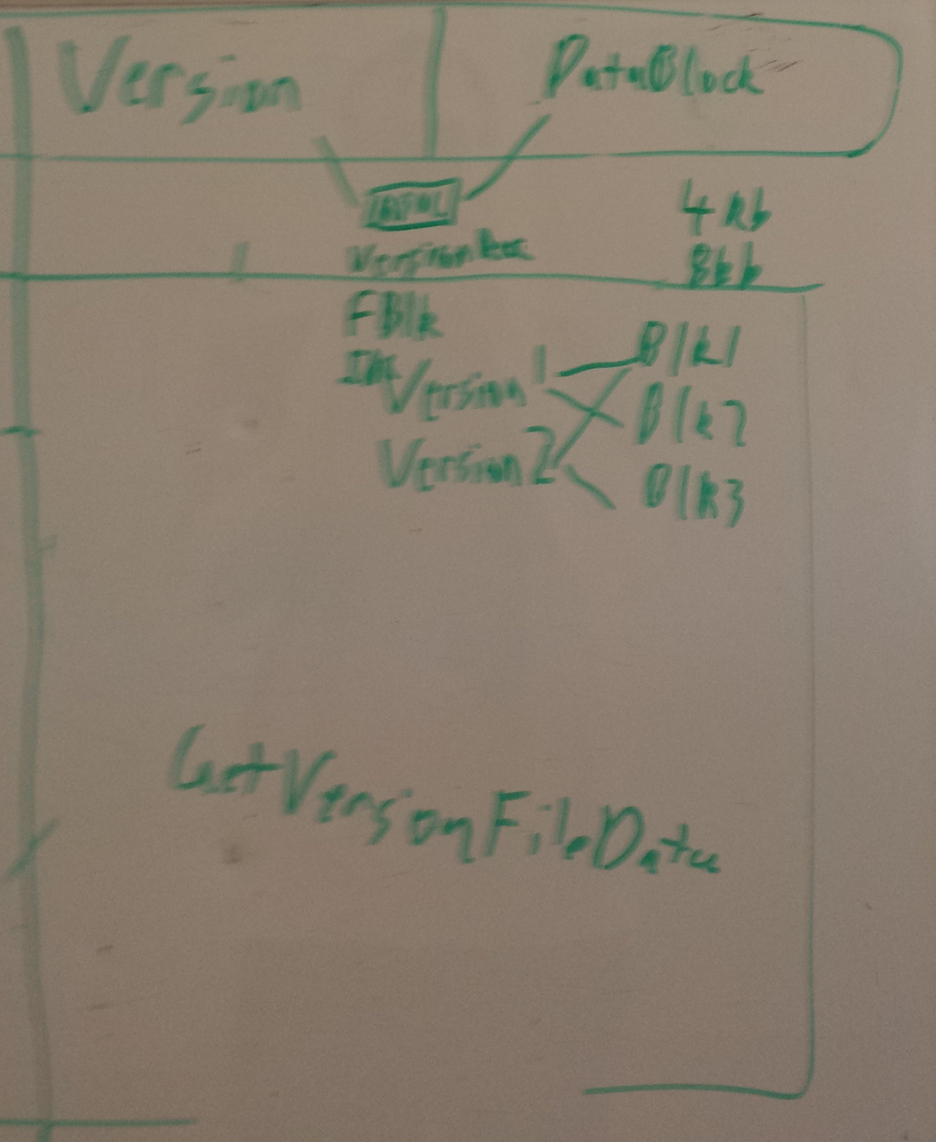After deciding on how to store the files we redesigned the database to better reflect what we wanted to achieve. Redundant tables and fields were removed.

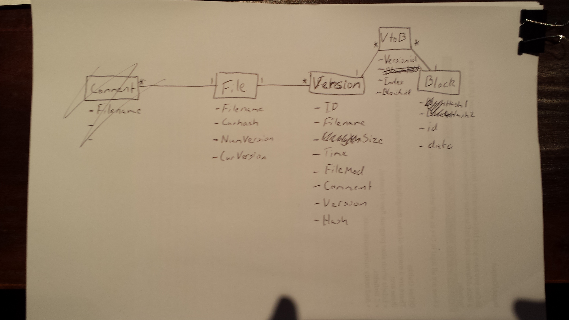

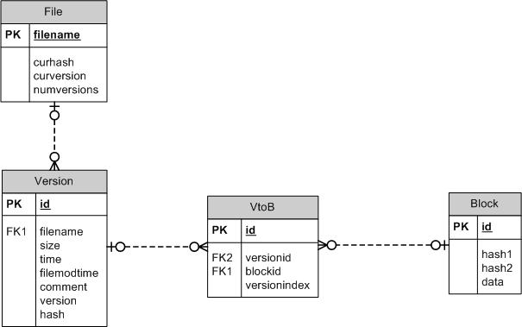An ERD was created to show how the database worked.

This is the database code at our first implementation. The insertion and retrieval of a File, Version, Block, and VtoB worked perfectly. **Need to talk about the hash1 and has**

